지옥에서 온 Git - 수업소개

Git: Version Management, not by changing the file name

1. Back up

2. Recovery

3. Collaboration

commit을 놓쳤을 때 add를 통해 특정 파일만 지정 가능

usage: git [--version] [--help] [-C <path>] [-c <name>=<value>]

[--exedc-path[=<path>]] [--html-path] [--man-path] [--info-path]

[-p | --paginate | -P | --no-pager] [--no-replace-objects] [--bare]

[--git-dir=<path>] [--work-tree=<path>] [--namespace=<name>]

[--super-prefix=<path>] [--config-env=<name>=<envvar>]

<command> [<args>]

These are common Git commands used in various situations:

start a working area (see also: git help tutorial)

clone Clone a repository into a new directory

init Create an empty Git repository or reinitialize an existing one

work on the current change (see also: git help everyday)

add Add file contents to the index

mv Move or rename a file, a directory, or a symlink

restore Restore working tree files

rm Remove files from the working tree and from the index

sparse-checkout Initialize and modify the sparse-checkout

examine the history and state (see also: git help revisions)

bisect Use binary search to find the commit that introduced a bug

diff Show changes between commits, commit and working tree, etc

grep Print lines matching a pattern

log Show commit logs

show Show various types of objects

status Show the working tree status

grow, mark and tweak your common history

branch List, create, or delete branches

commit Record changes to the repository

merge Join two or more development histories together

rebase Reapply commits on top of another base tip

reset Reset current HEAD to the specified state

switch Switch branches

tag Create, list, delete or verify a tag object signed with GPG

collaborate (see also: git help workflows)

fetch Download objects and refs from another repository

pull Fetch from and integrate with another repository or a local branch

push Update remote refs along with associated objects

'git help -a' and 'git help -g' list available subcommands and some

concept guides. See 'git help <command>' or 'git help <concept>'

to read about a specific subcommand or concept.

See 'git help git' for an overview of the system.

-Git 과거로 돌아가기

Reset vs revert

Reset은 실제로 삭제가 아니라 남아있음

Reset은 공유한 뒤로는 절대 사용하면 안됨

Revert 커밋을 삭제하지 않고 되돌리기

기본 지식만 다지고 + 모르는 것을 알아내는 법만 알면 무한히 성장 가능

원리를 아는 것이 중요한 이유

원리를 모르고 10시간 = 원리를 알고 3시간

Pip install gistory 로 다운로드

Gistory

Localhost:8805

Index

Objects안 /1. Commit 2. Tree 3. Blob(내용)

Git은 파일의 이름이 달라도 내용이 같으면 같은 ID를 씀

가끔 복잡한 정보를 검색할 때에는 이미지로 검색해라

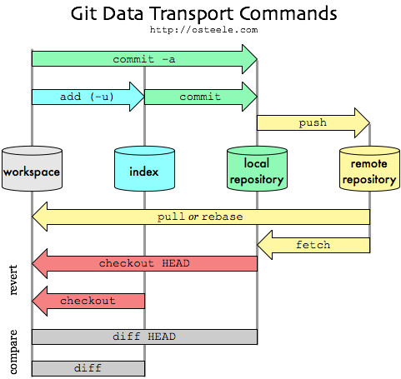

Branch

버전이 분기되었다가 병합할 때 사용

merge방법

1. fast-merge (빨리감기) : hotfix한것에 병합(덮어씌워짐)

2. fast-forward가 아닌 것(새로운 commit이 만들어짐)

배운건 써먹을 때 의미가 있다